**Xptdef 2 Tutorial**

**(by Guillaume Bonnefois)**

1. **Package installation from Github**

* devtools::install_github("leonpheng/xptdef2")
* devtools::install_github('davidgohel/ReporteRsjars')
* devtools::install_github('davidgohel/ReporteRs')
* devtools::install_github(“[benjaminrich](https://github.com/benjaminrich)/[PCSmisc](https://github.com/benjaminrich/PCSmisc)”)

Install additional packages from CRAN such as plyr, dplyr, SASxport, Hmisc and certara logo:

* install.packages()

1. **Library to be loaded in R Studio**

* library(xptdef2)

1. **Setup the working folder to save all define document:**

Example:

* working.folder="C:/Users/lpheng/Desktop/Test"

1. **Use the helps() function for a quick step-by-step procedure**

* helps()

stepBYstep Procedure

1 require(xptdef2)

2 working.folder= enter full path

3 step1(working.folder)

4 EDIT list of files.csv then save

5 define.library= path/libraryfile.csv

6 step2()

7 EDIT studydefinelist.csv and save.

8 step3(title)

1. **Run step1**

* step1(working.folder)

A file entitled “list of files.csv” will automatically be generated

* 1. **Edit** list of files.csv **file according to the following:**
* COLUMN A (filename) and COLUMN N (sourcepath):
  + enter file name including extension in column A and copy/paste the path in column N. Note that dataset files accepted are in csv and NONMEM tables, and program files in txt or csv format
  + **TIPS:** datasets should be listed first then programs by ordering from top to bottom (ex: pk dataset.csv, Residuals.csv, Eta.csv, final.mod)
* COLUMN B (t*ype*) for identifying the files (dataset or program)
* COLUMN C (rename) for renaming the files. Short names (~8-10 characters) should be used (ex: pkdataset, residualfin, etafin, finalmod).
* COLUMNs D (*keyvar*) and E (*Structure*): enter the key variables for the dataset only, and leave blank for programs. The *keyvar* and *Structure* would reflect the unique row of the dataset, example, *keyvar* = USUBJID, TIME and *Structure* = per subject per time point.
* COLUMN F (P*rogram*): if applicable, enter the name of corresponding program used to generate the dataset. The new name in column C should be used (ex: for Residuals.csv and Eta.csv, P*rogram* = finalmod).
* COLUMN  G (*description*): enter detail to describe each dataset and program (ex: PK dataset for metabolite, NONMEM control file of final PK model, etc.).
  1. **Setting Program Table for PMDA submission Using list of files.csv**

Note 1: For FDA and EMA submission, these columns H to M should remain blank (see Figure 1).

Note 2: For PMDA submission, all items (datasets, programs, scripts, dependency, etc.) related to TFL in the final report must be included. Ex: pkdataset (for modeling), eta (for boxplots and scatter matrix), residuals (for GOF), vpcoutputs (for VPC), programs, model, R script used, etc. Columns H to M should be completed as below (see Figure 2 for example).

COLUMN H (*progNo*): label all programs with unique tag (example, the BAD labels are 1, 10, 11, 111, since 1 is nested in other tags and 11 is nested in tag 111. The GOOD labels are unique like *#1a*, *#10a, #11a*).

COLUMN I (*Software*): enter platform version (ex: “*NONMEM version 7, R version 3.0.0”*)

COLUMN J (*Purpose*): example, “*the script used to generate Figures 5, 6 and 7 in the report and tables 2.1.1, 3.1.1 and 4.1.1. in Appendix 12*”

COLUMN K (*proNo.input*): ex: If *residuals* dataset was used as input for program *#1a* and *#2a* then enter *#1a#2a* in the *residuals* row.

COLUMN L (*proNo.output*): ex: If residuals is the output generated by program *#1b* then type in *#1b* in the residuals row.

COLUMN M (*progNo.dependent*): ex: If programs *#1b* and *#11c* are dependencies for programs *#1a* and *#2c* then type in *#1b#11c* in rows *#1a* and *#2c*.

Save "list of files.csv" and run line below:

* + - define.library="no"

or if library is available,

* + - define.library=“path+library name

**Figure 1: List of files example for FDA and EMA submission**

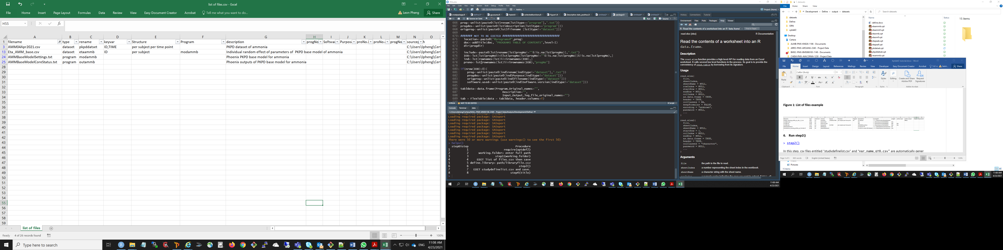

**Figure 2: List of files example for PMDA**

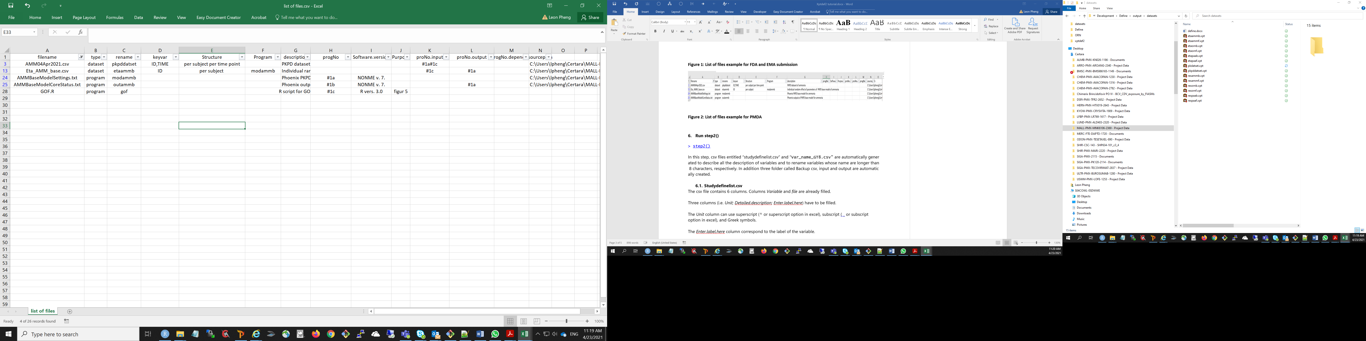

1. **Run step2()** 
   * + step2()

In this step, csv files entitled “studydefinelist.csv” is automatically generated.

Note that if library is available, the list will be merged with the library information.

* 1. **Edit Studydefinelist.csv**

Columns A (*Variable)* and F (*file) contain information extracted from datasets*.

Columns B, C and D (i.e. *Unit; Detailed.description; Enter.label.here*) have to be filled out.

Note: *Unit* column accepts superscript (^ or superscript option in excel), subscript (or subscript option in excel), and Greek symbols.

*Enter.label.here* column (D) correspond to the label of the variable. The number of characters should not more than 40.

.

The *Detailed.description* column (C) enable a precise description of the label. Example, for categorical variables, the numerical code must be provided, e.g. Sex of patients (0 = Female; 1= Male)

The *RESOLUTION* column (H) could be used to remove unwanted variable (H= remove) or to rename variable with “>8 characters” just by entering the new name in column H (see Figure 3).

**TIPS:** Create a library with the same format as **Studydefinelist.csv** for common variables. Information from dataset specification or SAP document can be used to merge with the **Studydefinelist.csv** using R or Excel (VLOOKUP function)**.**

**Figure 3: Studydefinelist example**

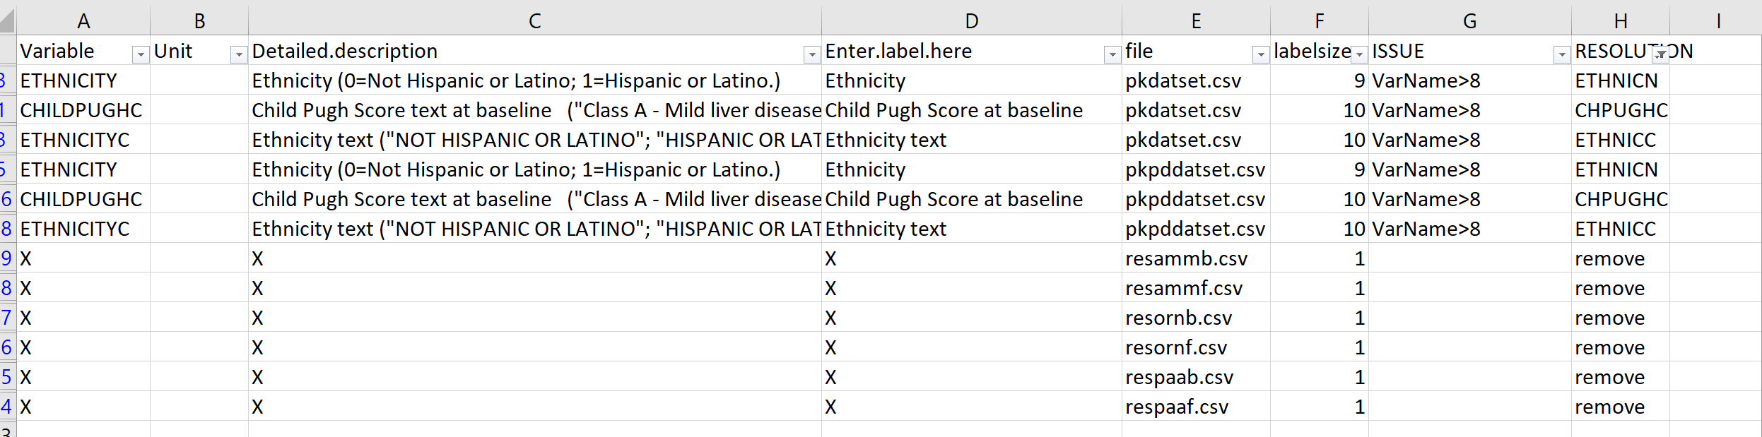

1. **Run step3()**

The step3 will correct the variable name (remove or rename), convert csv to xpt file and create define document.

Add title and run step3 as example below.

* + - title="Population Pharmacokinetic model for XX project"
    - step3(title=title)

Overall, xpt files and define.docx will be generated in output\datasets subfolder in step3 and txt files generated in output\programs subfolder in step2.

**TIPS:** to change the define location, used option define_location in step3. As default define_location= "./output/datasets/".

1. **Refine manually the Word document generated**
2. The word document entitled “define.docx” is located in the output\datasets sub-folder created in step 3. If applicable, replace “XXXX” with “_” and “#” with “\” using find/replace function in word.

TIPS

1. Edit and format all sections in the word document except for the Label column in section VARIABLE DEFINITION TABLES. The issues found in the Label column require corrections in **Studydefinelist.csv** and re-run of step3.
2. Certara logo could be added and convert the word document in pdf. Archive the define.docx copy and remove it from datasets folder.
3. Make document ready to be sent to client by putting “datasets” and “programs” folders in one zip file.

1. **Appendix**

library(xptdef2)

library(tidyverse)

library(ReporteRsjars) #not in CRAN

library(plyr)

library(dplyr)

library(SASxport)

library(Hmisc)

library(PCSmisc)